**Betty and Carl**

Betty and Carl are the parents behind the Patterson Family. Married for over 40 years and eight kids later it could be said that they truly knew how to live life. While Carl died several years ago Betty is still alive and giving her kids hell! She spends half of her time between Romaine’s house and her home state of Wyoming. With out Betty and Carl, Romaine wouldn’t even be close to the person she is today.

**Charles**

Charles is the oldest brother in the Patterson Family. He is an avid hunter and fisherman. He lives in Wyoming and is known to listen to Romaine’s radio show from time to time.

**[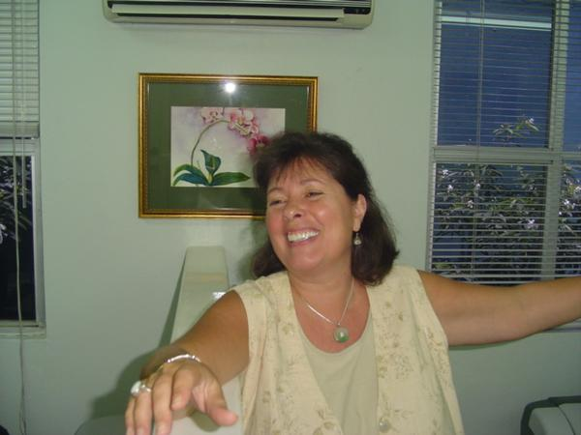](http://viewmorepics.myspace.com/index.cfm?fuseaction=viewImage&friendID=230262119&albumID=770030&imageID=5504213#a=770030&i=5504281)** **Trish**

Trish is Romaine’s oldest sister. She had moved out of the house before Romaine ever came along. She currently lives in Jamacia with her husband.

<http://www.facebook.com/album.php?aid=-3&id=1040155356>

**Michael**

Michael has a very special place in Romaine’s life. When he was alive they were very close. He died from AIDS complications in 1997. You can learn much more about their relationship by reading Romaine’s book. But Romaine will tell you that Michael was and has always been her hero.

 **John**

John is one of Romaine’s favorite siblings. He has an amazing partner named Jack and Romaine is always happy to take credit for pairing them up. John can often be found in just about any Sabina story as the two of them are very close. John lives in Denver, CO where he works as a real estate agent. If you are looking to buy a house or sell a house in Denver you should use him as he is the BEST! <http://www.leonardleonard.com/associates/patterson.shtml>

[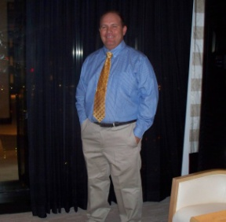](http://www.facebook.com/photo.php?pid=30070062&id=1040155356) **Patrick**

Patrick lives in Wyoming and enjoys hunting and fishing. He works in a coal mine and often works to hard! He is always playing pranks on the other Patterson siblings and is always good for a laugh.

 **Sabin**

Sabin is the brother that lives in NY with Romaine. When she first moved to NYC she stayed at his house and he has never let her live it down! He is an interior designer and you can visit [www.pattersondesign.com](http://www.pattersondesign.com) to see some of his work.

 **Sabina**

Sabina is perhaps the liveliest of all of the Patterson siblings. She has a personality that is unmatched by any other living person. She lives in Wyoming and works as a real estate agent. If you want to buy a house from someone who you will never forget working with you should give her a call. I promise you can’t imagine buying a house and having it be so much fun! <http://soldbysabina.com/>

 **Iris**

Iris is Romaine’s partner. She was once a listener of the show but was not a fan of Romaine’s. They met at a pride event and started a long distance relationship as Iris was an active member of the US Air Force at the time. After dating for a year Iris left her job at the Air Force and moved to NJ to be with Romaine. One year later, they bought a house and got pregnant all in the same week! They live together with their daughter Romie in NJ.